**Phase 4: Process Automation (Admin)**

Goal: Automate tasks.

1. **Validation Rules**
   * Appointment Date must be not from past.
   * Delivery Date must be not from past.

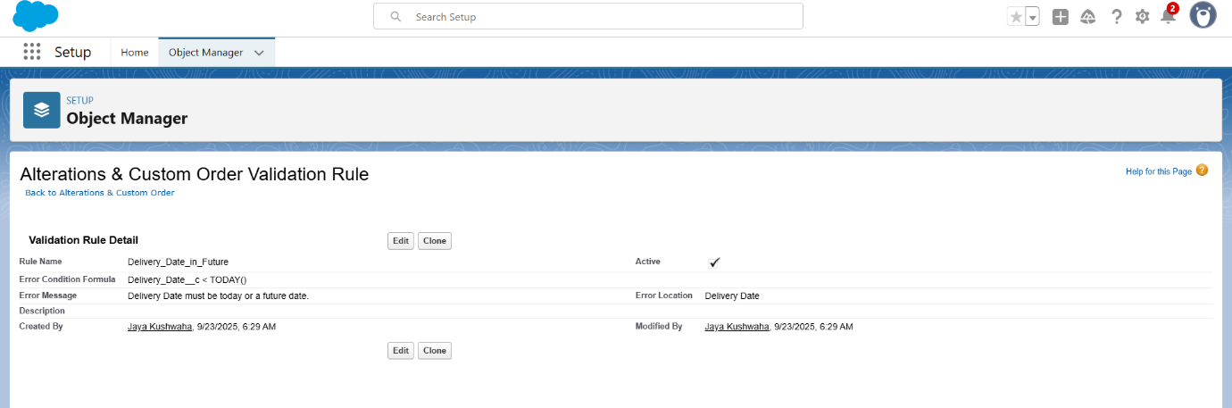

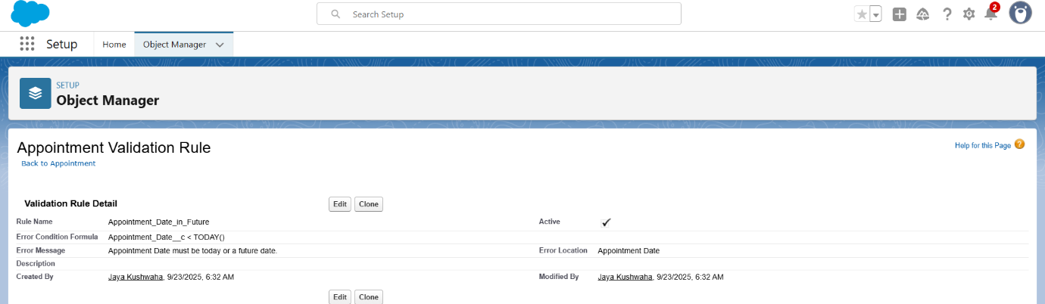

1. **Email Alerts**
   * Customer email after approval.

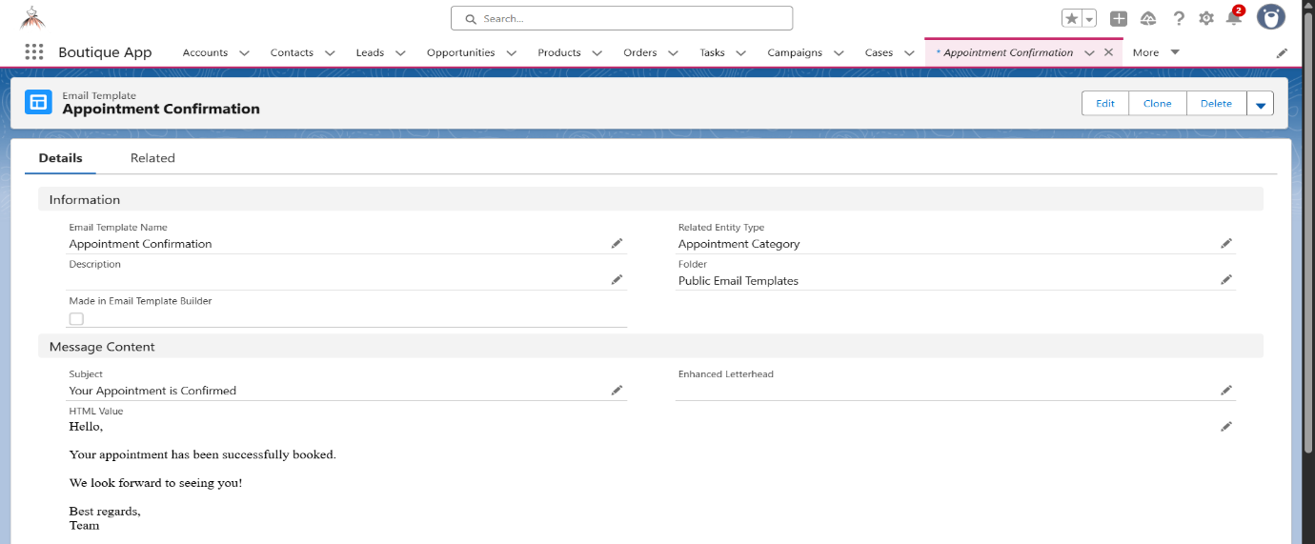

1. **Field Updates**
   * After the Appointment is done the Status is updated to “Completed”.

